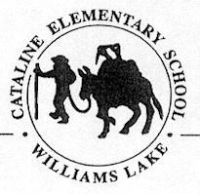

Cariboo-Chilcotin School District
2021-2022 School Plan for Learner Success

School Name: Cataline Elementary School

Ministry of Education Framework: A shared commitment to improve student success, equity and inclusivity of learning outcomes for all students with a particular focus on Indigenous students, children and youth in care and students with disabilities or diverse abilities.

Circle of Courage: (Brendtro, Brokenleg, Van Bockern, 1990) emphasizes the four growth needs of all children: Belonging, Mastery, Independence, and Generosity. This model informs teaching and educational decision-making in the District and is expected to be considered in school planning for learner success.
Intellectual Development
Educational Outcome 1: Students will meet or exceed literacy expectations for each grade level
2020-2021 Results:
- Percentage of students meeting or exceeding literacy expectations:
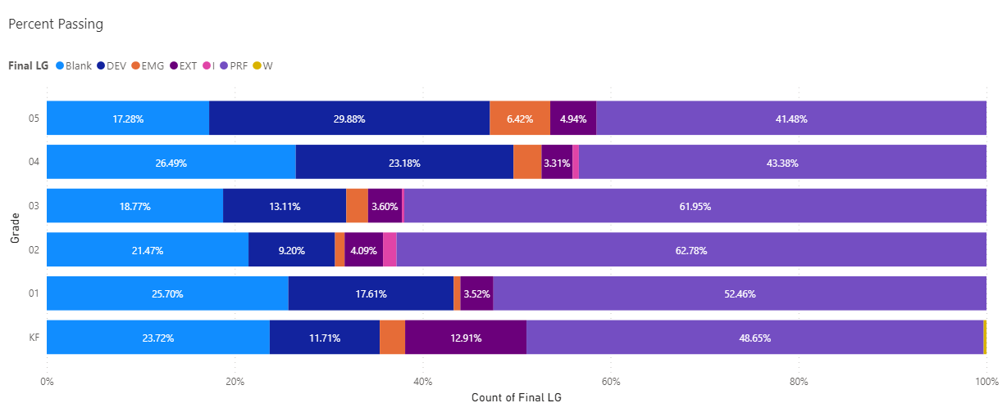

Open in Power BI

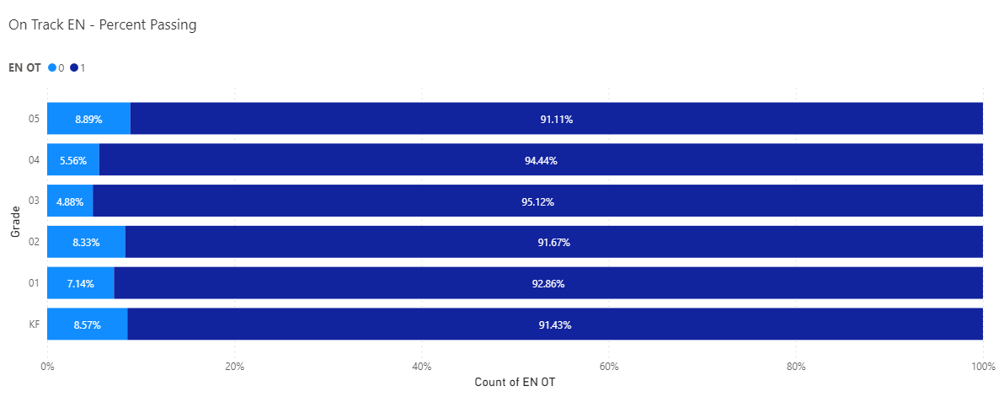

June 2022 data
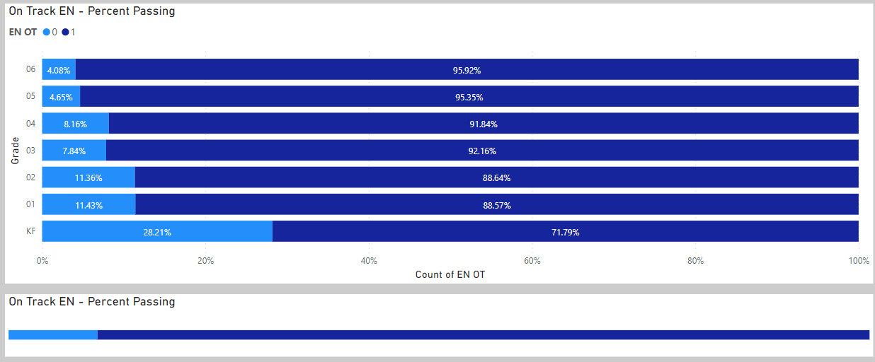
DART/EPRA
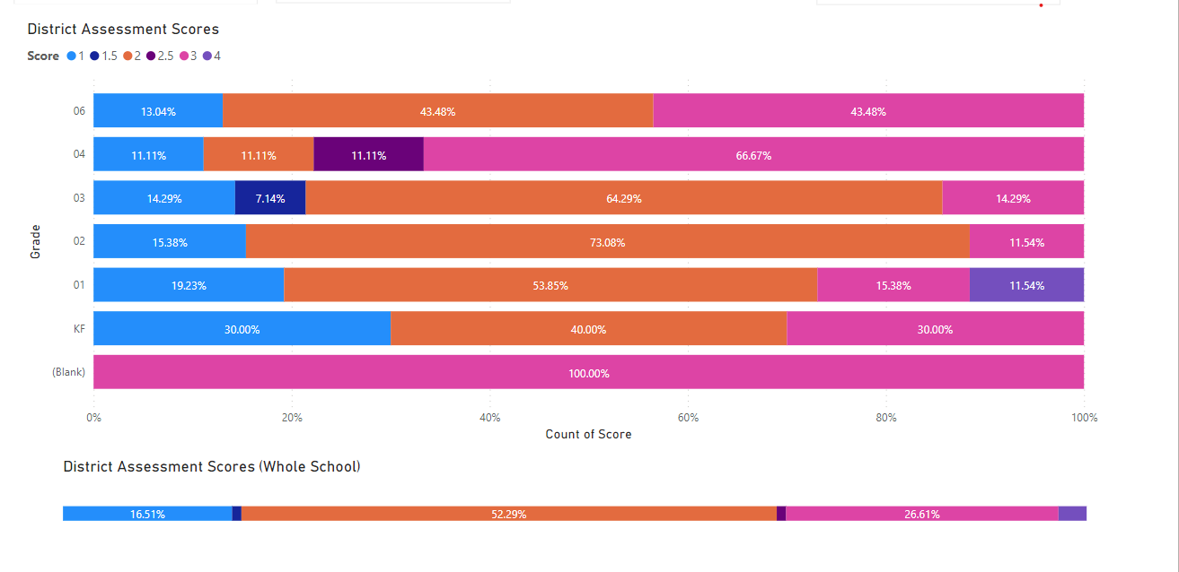
School Wide Write
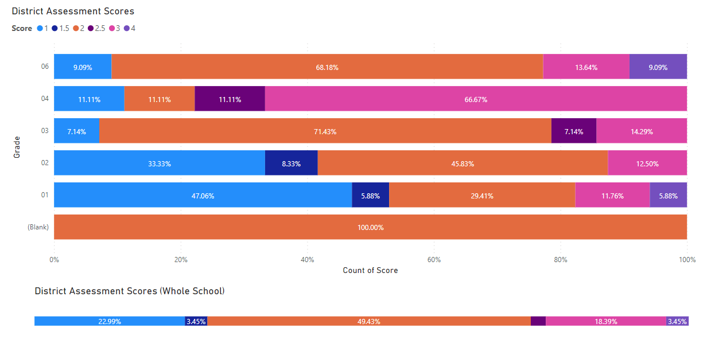
2021-2022 Goals and Focus Areas:
- Process driven instruction - looking at scope of sequence and intentional teaching according to needs of individual students
- Looking at the DART/EPRA data and gleaning information that will drive teaching to learning needs
- Looking at writing assessment data to drive teaching
Strategies and Structures:
- Actions for Enhancing Student Learning and Experience
- Differentiated instruction (meeting students where they are at)
- Increase daily writing across the curriculum - With formative feedback will have opportunity to learn and improve
- Actions for Enhancing Staff Capacity & Learning
  - Collaborative capacity building with LST (using literacy scope and sequence document created by Cataline staff) built into weekly schedule using Buddy Time schedule to free up teachers.
  - AFL practices to be explicitly discussed
Reflection: PLC was successful in opening discussion and beginning to learn with teachers. Understanding of how to administer DART/EPRA and SWW improved greatly over the year, as did the understanding of what to do with the assessment information.
Writing across the curriculum was discussed and we did see some growth in this area; however, this is a work in progress and will continue to be worked on next year. It is interesting to note that the grade 1 and 2 school wide writes show that on average 45% of students are emerging or developing whereas the grade 3-5 students only have 9% emerging or developing. We wonder if this is due to COVID in their K and 1 years…high absenteeism and/or home learning. We see the same variation in the DART/EPRA results but not as dramatic a difference.
Discussions about how to support all students and find access points in the curriculum were rich and showed growth in teacher learning. We are more aware of tools that can be used and how to read the curriculum, but more work needs to be done in this area to ensure all students are accessing grade level curriculum. Teachers did well supporting emerging students with at-level work in various formats (individual instruction, small group guided instruction, with EA support and through LST support).
We shifted one of our LSTs time to include more team teaching. This was very successful and allowed a collaborative approach to improve instruction and assessment on a whole class level.
AFL – teachers worked on making learning intentions more intentional and visible to students. This is also something we will continue to work on next year.
Data shows that we have improved slightly in literacy when comparing last year’s end grade 3 marks and this year’s FSA scores.
Educational Outcome 2: Students will meet or exceed numeracy expectations for each grade level
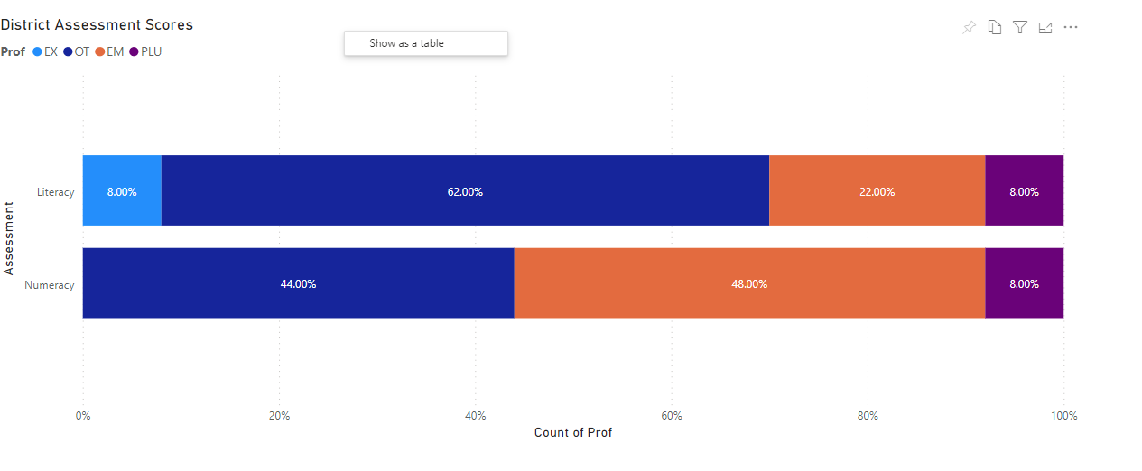
2020-2021 Results:
- Final Letter Grade Math
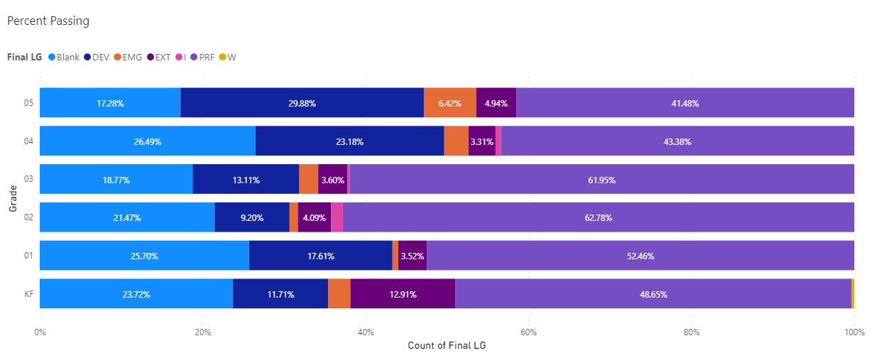

Open in Power BI

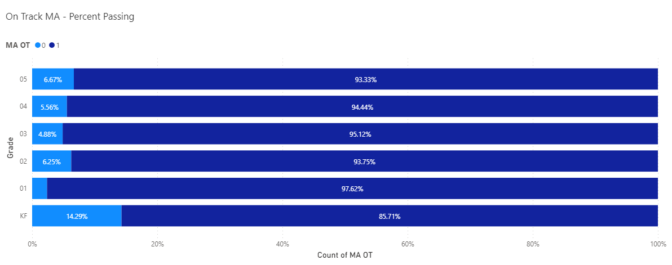

Open in Power BI
June 2022 data

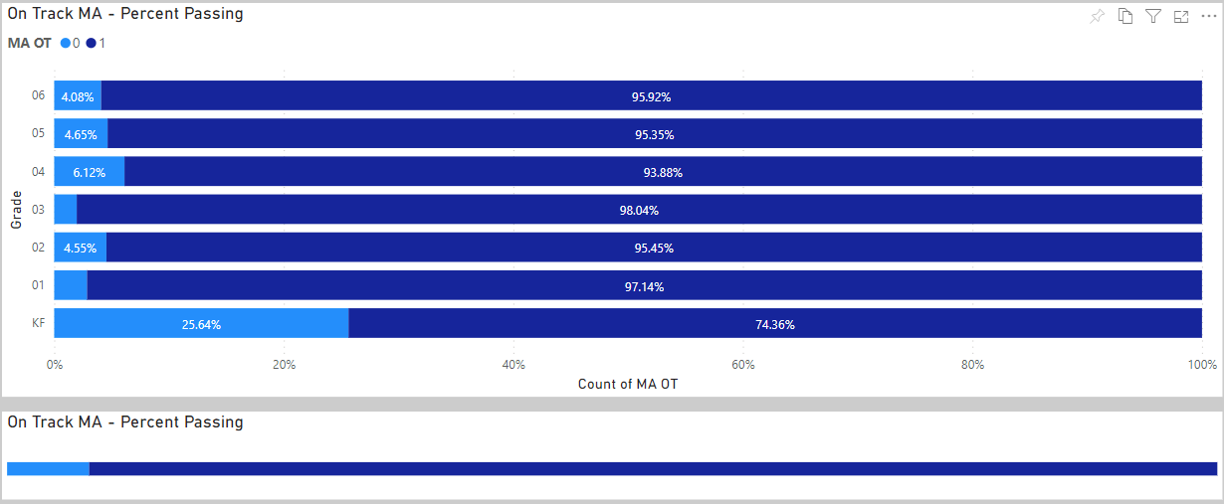

2021-2022 Goals and Focus Areas:
- Ensure all students are working with grade level material– supporting with tools as needed
- Teaching with differentiation and hands on learning

Strategies and Structures:
- Actions for Enhancing Student Learning and Experience
  - Using guided instruction approach to meet students where they are at
  - Using Peter L and Carolle Fullerton strategies to get students engaged and working together
- Actions for Enhancing Staff Capacity & Learning
  - Carolle Fullerton Pro-D and resources
  - Peter L Pro-D and resources
Reflection:
The most growth in this area has been in the openness of staff to discuss alternate ways of teaching concepts. Many PLC conversations and collaborative meetings between teachers focused on how to engage all learners in the lesson using various tools/strategies (ie Carolle Fullerton/ Peter Liljedahl). There is a greater understanding of the importance of all students working with grade level material. Teachers have begun to learn how to find access points for all students while also supporting students in developing basic skills at their level. This is something we will continue to work on with staff next year and will encourage all to attend the learning series to gain better understanding.
What we noticed when looking at data is there is a large discrepancy between FSA and teacher marks. Foundational skills seem to have been missed over the COVID years…This tells us that we need to focus on for assessment and general understanding of the curriculum and what is expected at each grade level.
Human and Social Development
Educational Outcome 3: Students will feel welcome, safe and connected to their school
3. 1 Attendance
2020-2021 Results:
- Percentage of students attending 80% or greater end of June 2020:
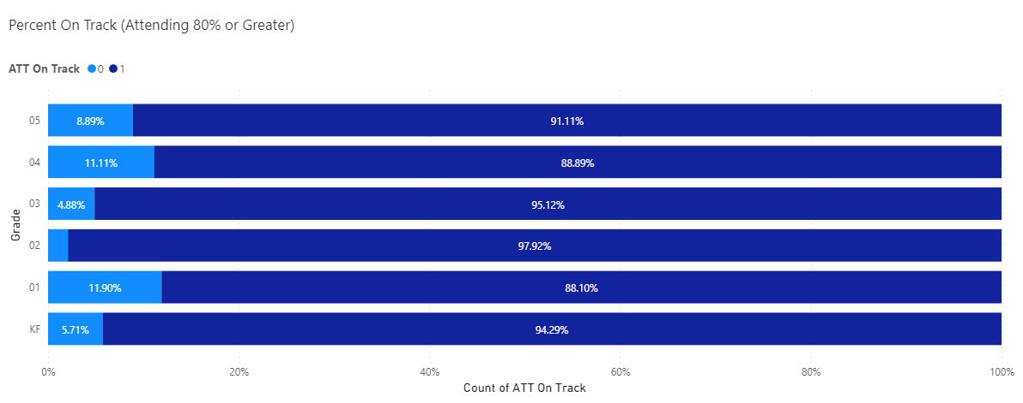

Open in Power BI

June 2022 data
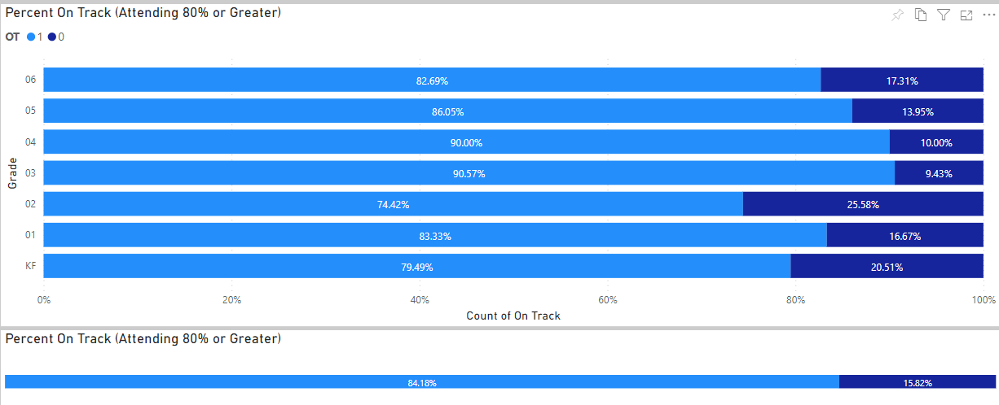
2021-2022 Goals and Focus Areas:
- 100% of students attending 80% or greater end of June 2021
- Connecting with families to provide support (wrapping around)
  - Offering alternatives to get kids to school
  - Welcoming students no matter what time of day they arrive at school
Reflection: We were close to meeting our goal of all students attending more than 80% of the school year. For high absenteeism amongst certain students, we called to check in and touch base. We were able to secure bussing for a child that was unable to make it to school otherwise, even though he was “too close to school” to qualify. We changed our late slips to welcome slips and all staff were welcoming when they would arrive.
3.2 Connection to School
2020-2021 Results

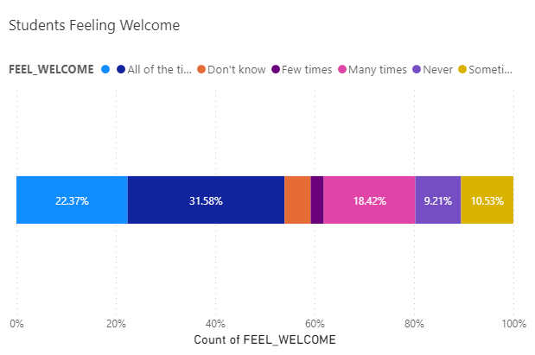
June 2022
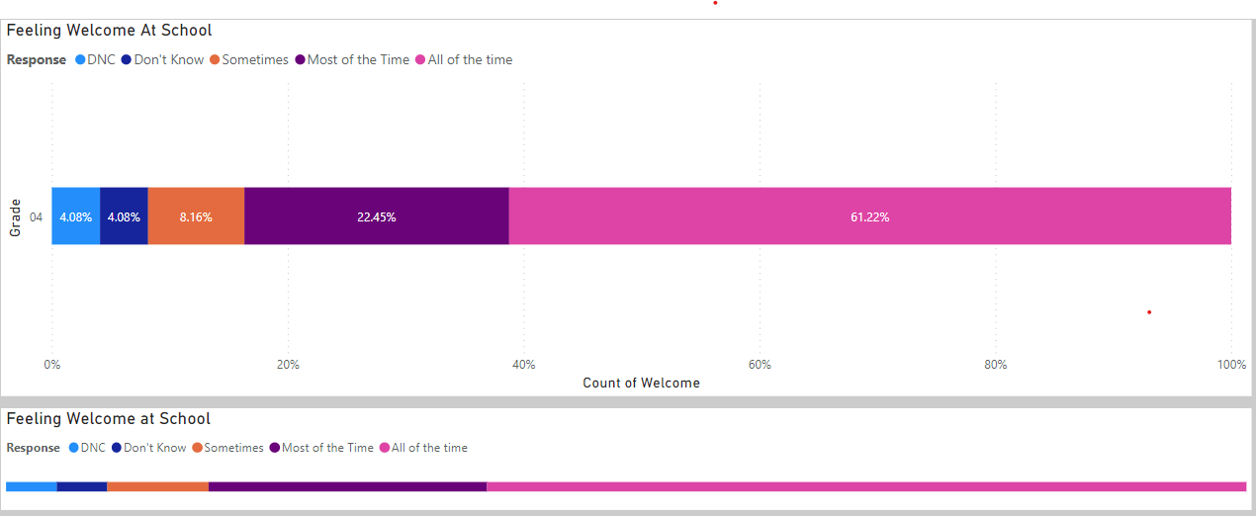

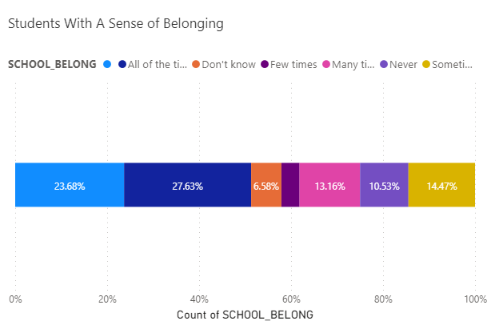

Open in Power BI

June 2022

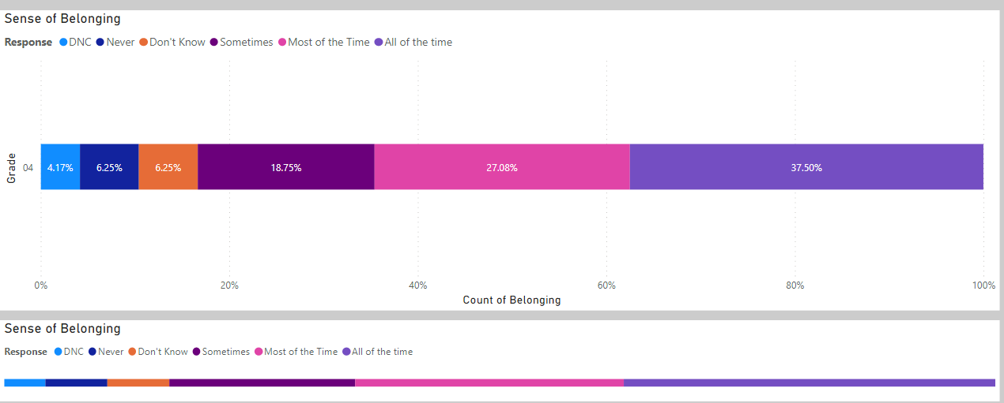
Goals and Focus Areas
Have 100% of students feel like they belong, are welcome and have 2 adults they can go to
Strategies and Structures
- Actions for Enhancing Student Learning and Experience
- Meeting and greeting students at the door every morning (not just letting them in)
- 2x10 strategy in all classes
- Using data and teacher knowledge – tag specific students who are vulnerable, don’t feel like they are welcome or belong with specific teachers for intentional 2 tags a week
- YEW worker outside during break times to offer activities for kids “lost”
- Offerings of lunch time sports in gym or outside, games in the library or outside, crafts etc
REFLECTIONS
We have seen huge growth as shown in the data in both the area of students feeling welcome all and most of the time: 2021 - 31.58% and 2022 – 61.22%. this is an increase of almost 30%. Our data shows that the percentage of students who feel like they belong most or all of the time have increased 23% this year, from 41% in 2021 to 64.5% in 2022. We have worked hard as a staff to put our strategies mentioned above, into practice. We did not tag specific students with specific teachers, but all staff were aware of our vulnerable students needing extra connection and were intentional about connecting. Being out of COVID restrictions has assisted us in reinstating sport teams which was also a positive action. One additional strategy we implemented was creating welcome cards rather than late slips. We always welcomed them at whatever time they arrived, without judgement. Finally, the culture amongst the staff in the school had a positive tone this year, continually keeping children and their best interests at the center of conversations. Continued emphasis on trauma effects and strategies to help were also instrumental in staff growth and students feeling welcome and that they belong.
3.3 Careers and Core Competencies
Book study as part of each staff meeting – Teaching like a pirate
Job applications and Core Competency (word of the week) with bulletin board for students to tack up how they’ve attended to the core competency subset
Other Focus Area
Collaborative Practice:
- Teacher preps scheduled with team teacher
- Focus on team teaching: strengths-based approach for teachers as well – sharing our skills/knowledge
- Collective responsibility for students
- Collaborative time (Buddy Time) built into the weekly schedule: focus is literacy and assessment practices (the “what now” of assessments)
- Yvonne and Kelly to block time in their schedules to allow for team teaching or teacher release time
- SBT practice: improving parent communication and participation in the process
Reflection – Scheduling buddy time/PLC time into our schedule was very advantageous for teacher collaboration. A sense of team and collective responsibility was fostered, and we are moving toward being on the same page for assessment. SBT meetings have greatly improved with having parents join our meetings.
School Team Meeting Schedule:
Staff meetings in September, December, March and June
Glossary:
SBT – School Based Teams

